25 February 2026
NAME: AISHA ABDULLAHI | Age : 23y | Sex: F | Ref No:00010
Clinical Details: USG Pelvic |  |  | US:10

REAL TIME PELVIC ULTRASONOGRAPHY EXAM: REVEALED:

URINARY BLADDER: Distended with urine with normal mucosal thickness. No gross masses or stone seen.

UTERUS: The uterus is gravid and shows single gestational sac with double decidual sac sign, yolk sac and embryo are not yet seen in the uterine cavity.

ADNEXAE: Both adnexia appeared preserved.

GSD = 16 mm.
EGA = 06 weeks 04 days.
EDD = 21/10/2026 ± 2weeks.

CUL-DE-SAC: No sonographic abnormalities detected in anterior and posterior cul-de-sac.

CONCLUSION: Early Cyesis at 06 weeks 04 days

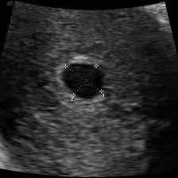
Ultrasound Specialist

